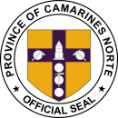[Your Name]

[Your Address] [City, State, ZIP] [Email Address]

[Phone Number] [Date]

Museo Bulawan

3 Justo Lukban St, Daet, 4600 Camarines Norte, Philippines

PROVINCE OF CAMARINES NORTE

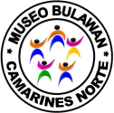**MUSEUM, ARCHIVES AND SHRINE CURATION DIVISION**

**Subject**: Appointment for Visitation at Museo Bulawan

Dear Museo Bulawan,

I hope this letter finds you well. I am writing to request an appointment for a visitation at your esteemed museum. I am eager to explore the rich cultural heritage and historical artifacts that Museo Bulawan has to offer, and I would greatly appreciate the opportunity to enhance my understanding of Camarines Norte's captivating past.

To assist in arranging this visitation, I kindly request the following instructions:

1. Appointment Date and Time: I would appreciate it if you could provide me with available dates and time slots for the visit. Please let me know which day and time would be suitable for my visit.
2. 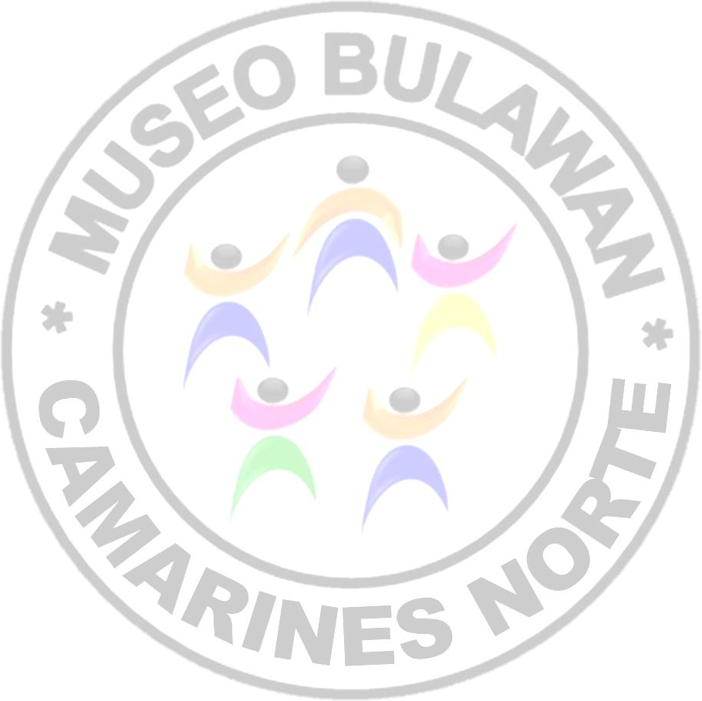Group Size and Participants: Please inform me if there are any restrictions regarding the number of individuals allowed per group. Additionally, if there are any specific requirements or guidelines for visitors, kindly let me know in advance.
3. Contact Information: Please provide me with the appropriate contact person's name, email address, and phone number, whom I can reach out to finalize the details of the appointment.
4. Special Interests: If there are specific areas of interest or particular exhibitions within Museo Bulawan that I should prioritize during my visit, kindly inform me in advance so that I can plan accordingly.

Thank you in advance for your kind assistance and prompt attention to my request. I look forward to receiving the necessary details for scheduling my visitation. I am excited about the opportunity to immerse myself in the rich cultural heritage preserved within the walls of Museo Bulawan.

Please feel free to contact me at [Your Email Address] or [Your Phone Number] should you require any further information or clarification. I eagerly await your response.

Yours sincerely, [Your Name]